|  |  |
| --- | --- |
| Diploma in Computer Engineering  Diploma in Infocomm & Network Engineering  Computer Game Programming (CGP) |  |

Project Report (save report as PE0xTy.doc where x is class no. and y is team no.)

*(eg. PE01T3.doc)*

|  |  |
| --- | --- |
| **Class (lab):** | **PE02** |
| **Team Number:** |  |
| **Name of Game** | **Adventures of a man** |
| **Genre** | **Maze/RPG/FPS** |
| **Matric No** | **Name** |
| **1203030J** | **Ong Tze Ang** |
| **1201289D** | **Lim Guan Ji** |
|  |  |

**About the App** (**brief** description about the Game application)

This game has a story about man taking on the world of angels and devils, heaven and hell. Being in a world not meant for humans, its population was wiped to one man. This game will test your reaction, speed, skill and brains.

**GUI**

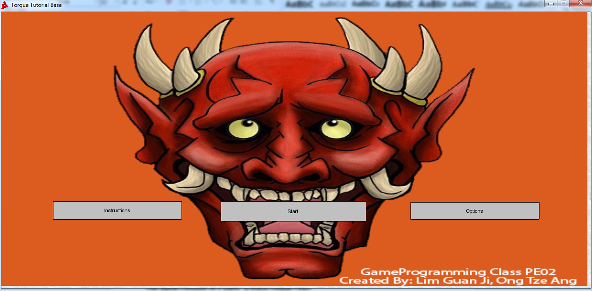

**Instructions**

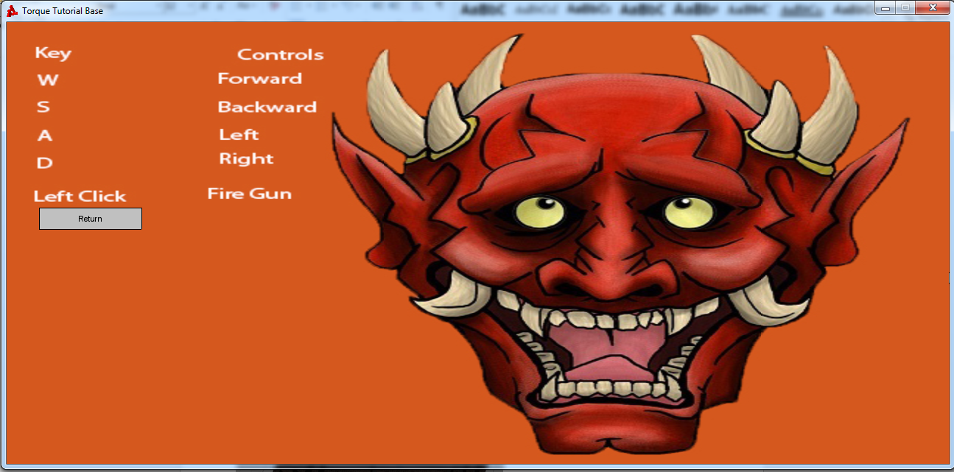

**How to play the Game**

The game consists of 2 parts, a maze (Stage One)

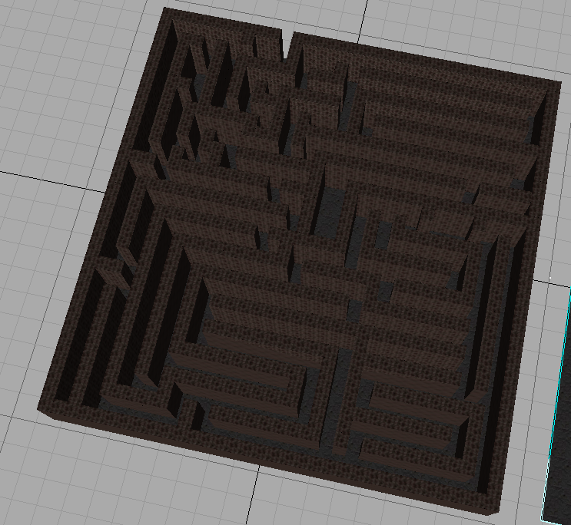

and a tower (Stage Two).

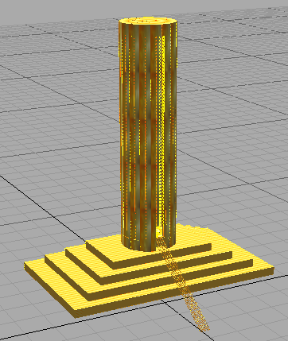

Proceeding through the maze, you will encounter two portal which teleports you to two different mini-game respectively.



Completing the mini-game will allow you to unlock clues to proceed through the maze. Mini-game one will present you with a platform jumper situation where one must jump through without falling within 300 seconds, else will be greeted with death.

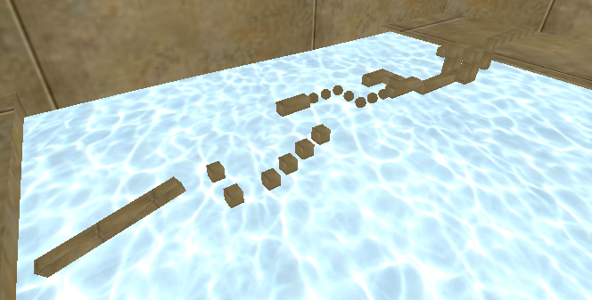

Mini-game two is also a platform type however instead of jumping through, you have to brave through enemies which will constantly barrage you with bullets within 300 seconds, falling also results in death.

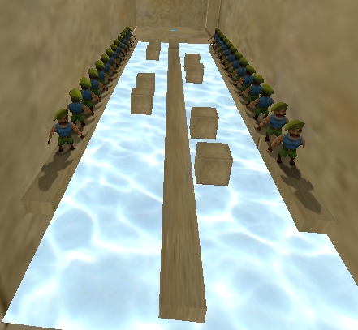

Finishing the maze will teleport you to land where you walk towards stage two, the golden tower.

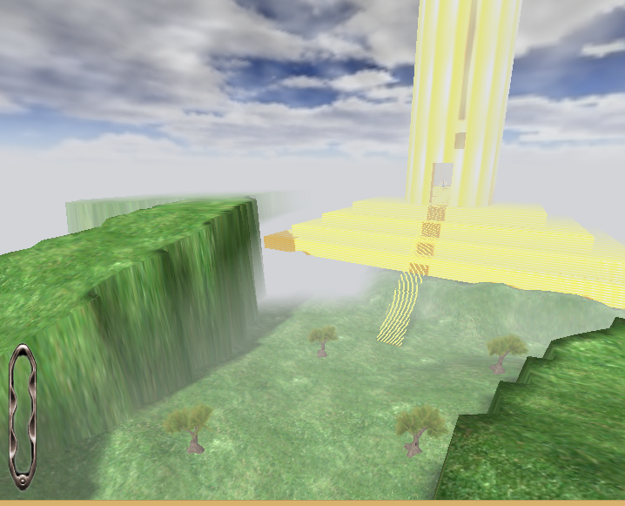

Next Stage Terrain

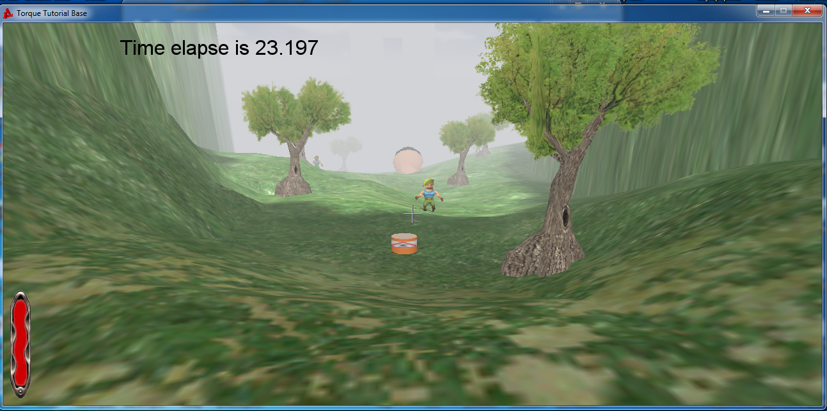

Rotating bomb is spawned if player steps on it it does 9999 otherwise just stay on position and let bob steps on it.

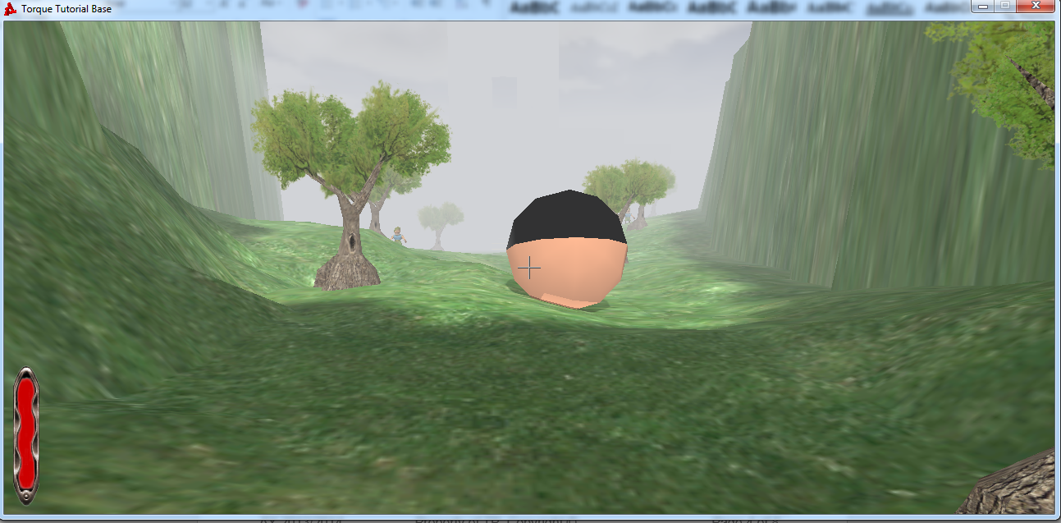

Upon Reaching the next terrain, You will be armed with a rocket launcher and a boulder will be spawn once you leave the trigger set to roll to its location. And 3 bobs will be spawned. It will be an instant death upon touching the boulder.

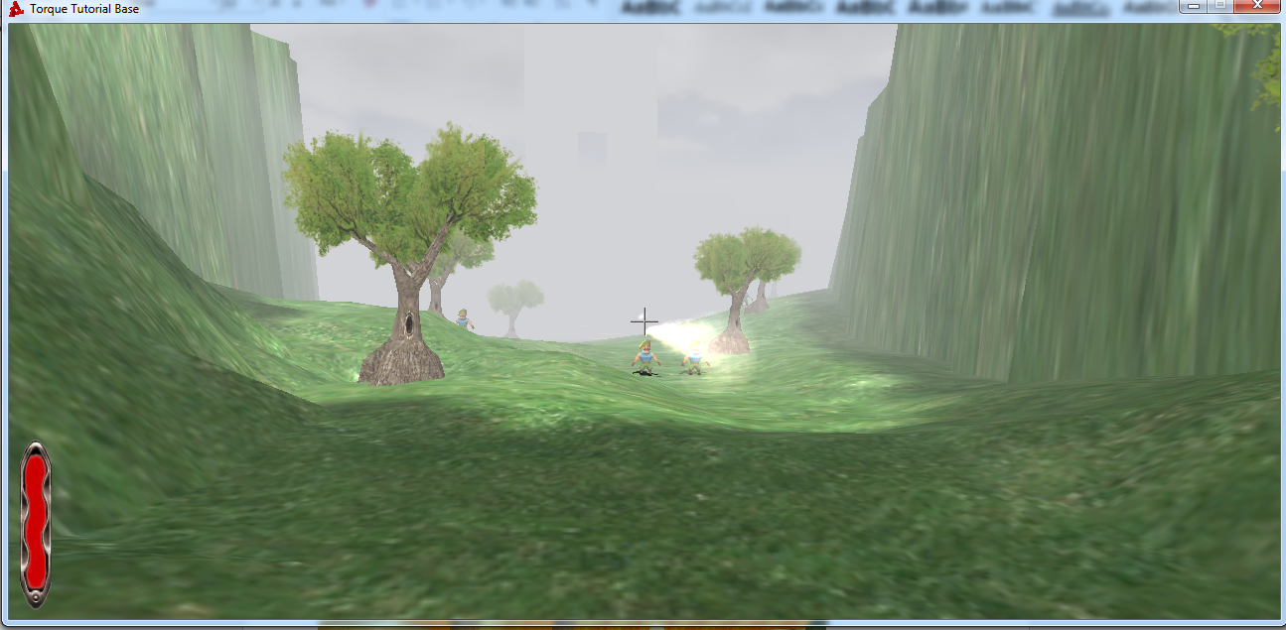

If boulder is destroyed, many bobs will be spawn at boulder location.

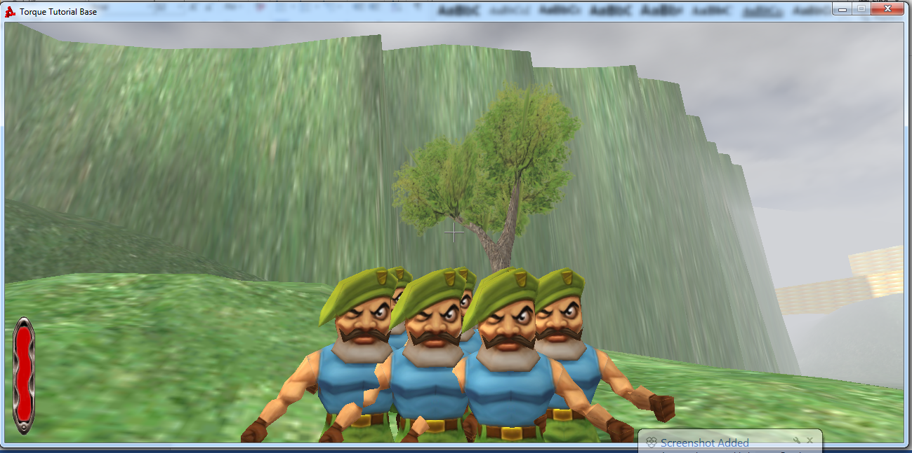

Bob is sets to want blood he does damage upon collision.  
Kill bob and proceed make him cry and proceed

Upon reaching the entrance of the tower, you will be equipped with a crossbow and an increase in damage, you will be requested to walk to the middle.

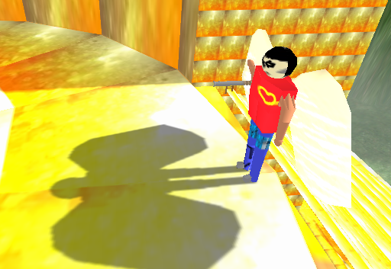

Walking to the middle prompts you with a yes no box. Clicking yes will teleport you to the boss battle where 3 Bob (Normal enemy) and 1 Oni (Boss) will spawn and attack you immediately.

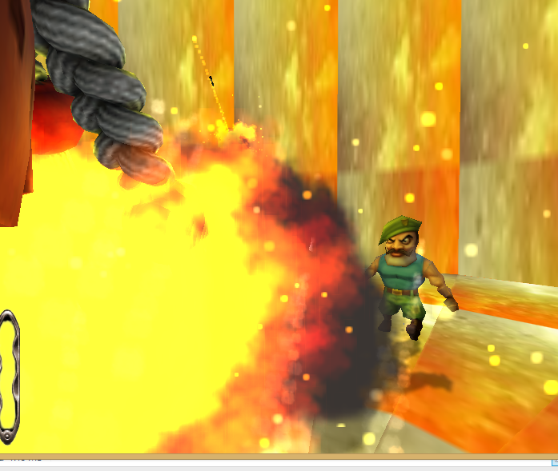

Slaying them all will win you the game. And celebration song will be played.

You have 20minutes to complete the game

**How resourceful are your team ?**Project Resources used:

TorqueScript Reference Guide v1.11

Starter.fps

A bunch of URL’s from:

<http://www.garagegames.com/community/forums/>

<http://torque3d.wikidot.com/>

<http://docs.garagegames.com/torque-3d/official/content/documentation/>  
http://www.garagegames.com/community/forums/viewthread/128456

and more.

Switching of weapon upon entering trigger  
  
  
  
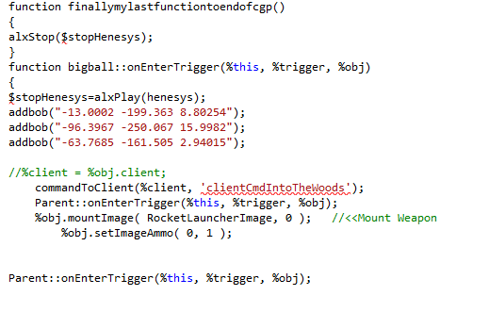  
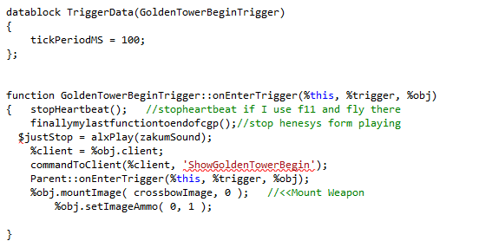

Storing AlxStop inside global variable to stop music 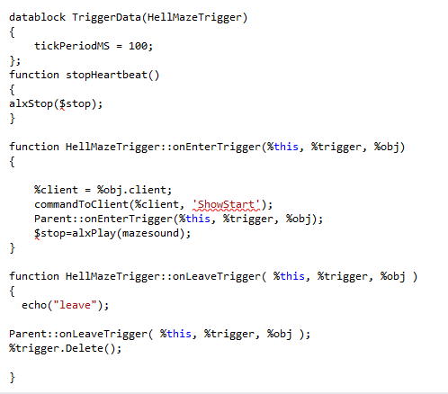

And to Play another music different music is being playing at each stages, destroyed of monsters,boulders, upon death, upon victory, entering triggers.

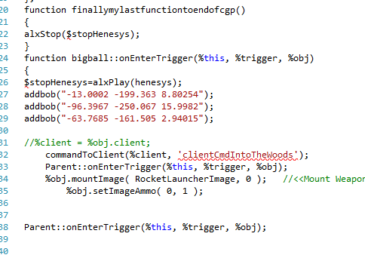

**Technical Info about the Game App**

**Timer in countdownClock.cs**

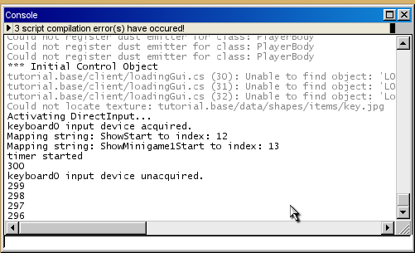

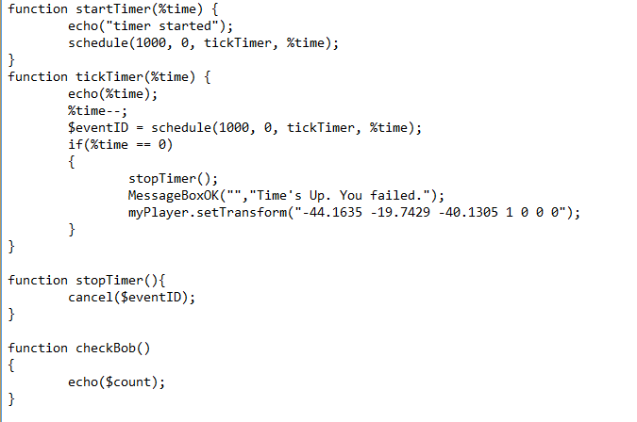

**Options page**

